カエルのへそ2024

step01

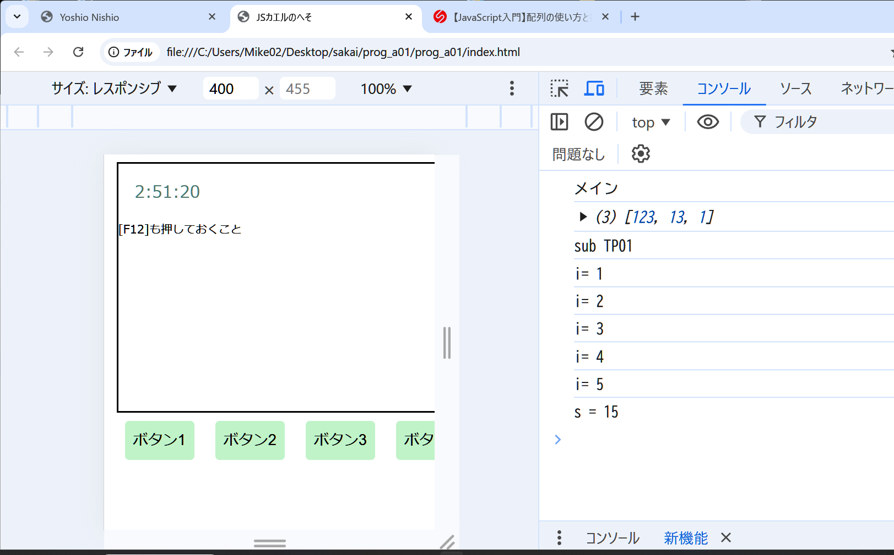

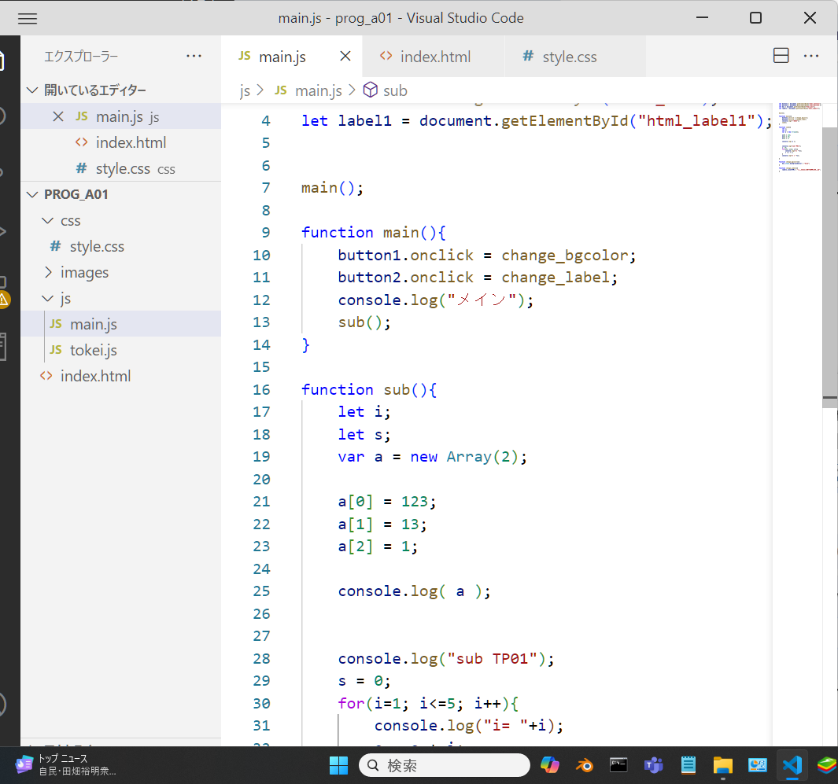

let button1 = document.getElementById("html_button1");

let button2 = document.getElementById("html_button2");

let box = document.getElementById("html_box");

let label1 = document.getElementById("html_label1");

main();

function main(){

    button1.onclick = change_bgcolor;

    button2.onclick = change_label;

    console.log("メイン");

    sub();

}

function sub(){

    let i;

    let s;

    var a = new Array(2);

    a[0] = 123;

    a[1] = 13;

    a[2] = 1;

    console.log( a );

    console.log("sub TP01");

    s = 0;

    for(i=1; i<=5; i++){

        console.log("i= "+i);

        s = s + i;

    }

    console.log("s = "+s);

}

function change_bgcolor(){

    box.style.backgroundColor = "blue";

}

function change_label(){

    label1.innerHTML = "ボタン2を押して書き換えた。";

}